**2. Reading Cell Library information and Netlist for APR**

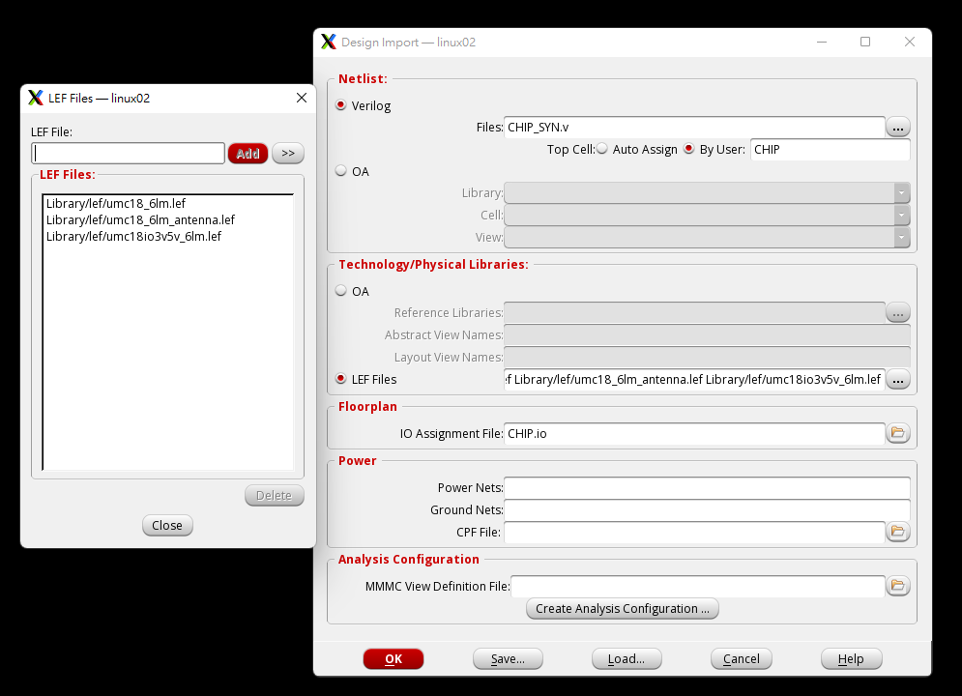

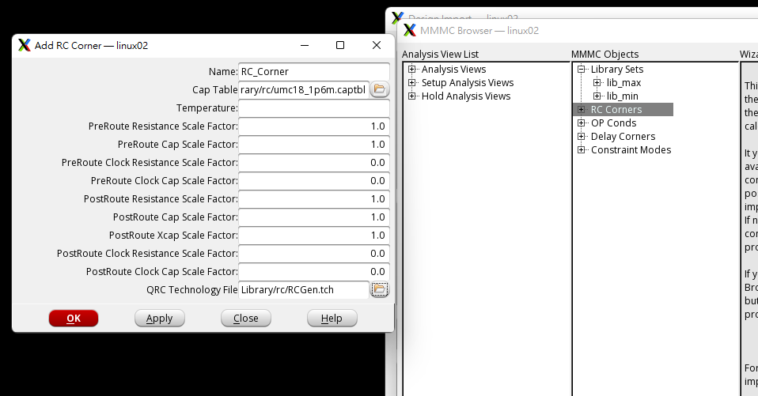

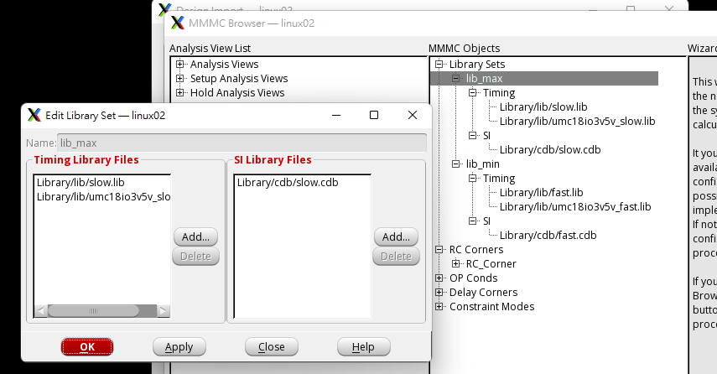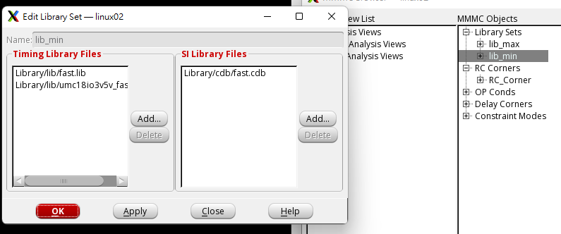

**4. Connect/Define Global Net**

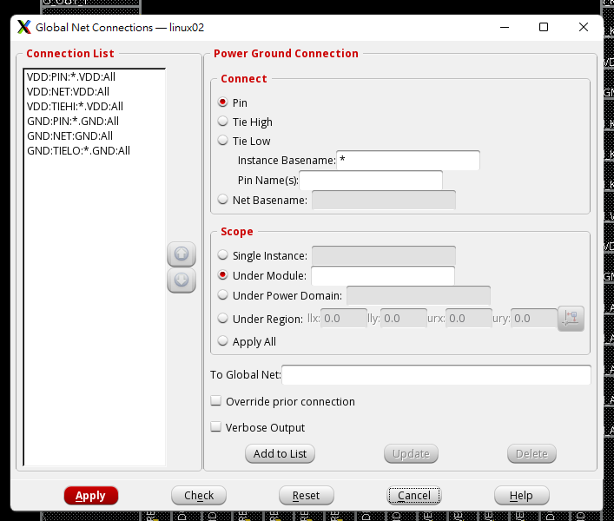

**5. Power Planning (Add Core Power Rings)**

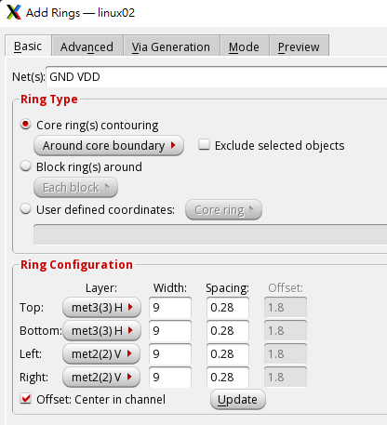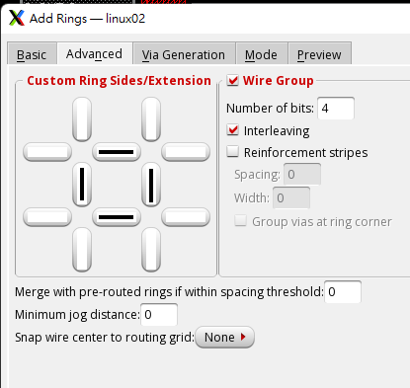

Pass block ring because no hard marco

**7. Connect Core Power Pin**

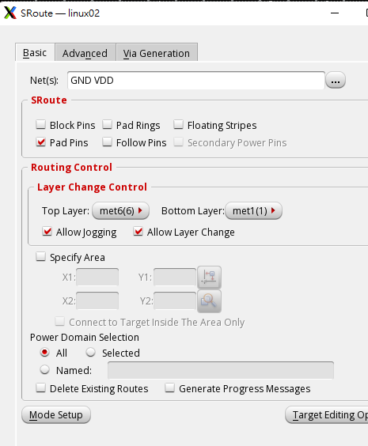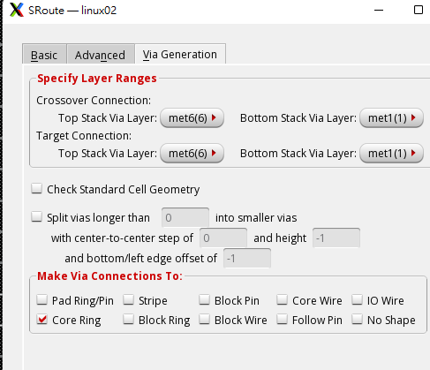

**8. Power Planning (Add Stripes)**

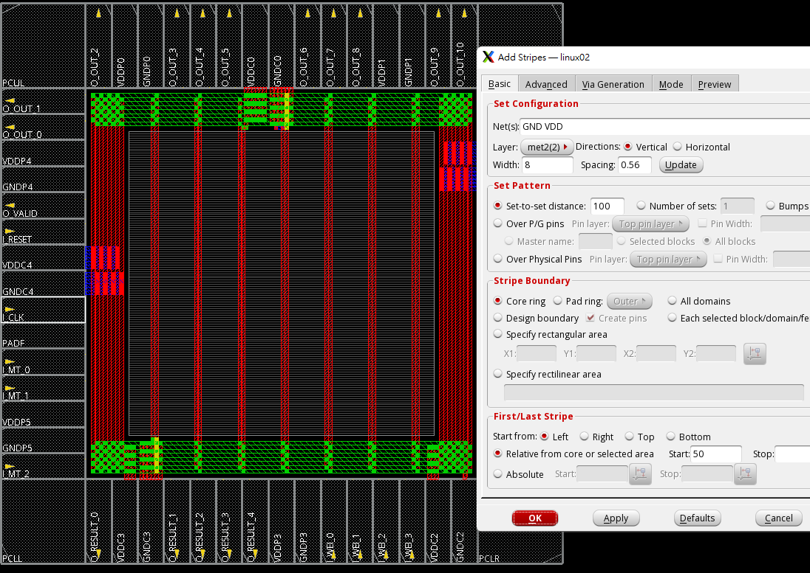

vertical

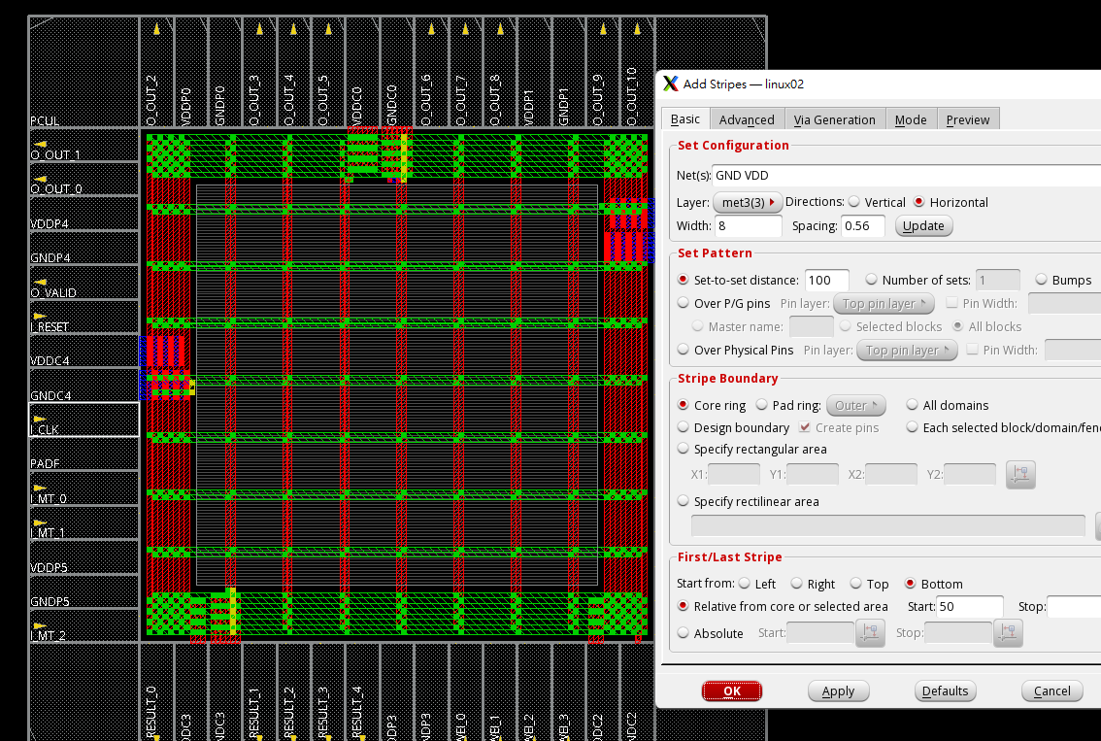

horizontal

不知道這樣行不行

待會存兩個檔案

**9. Connect Standard Cell Power Line**

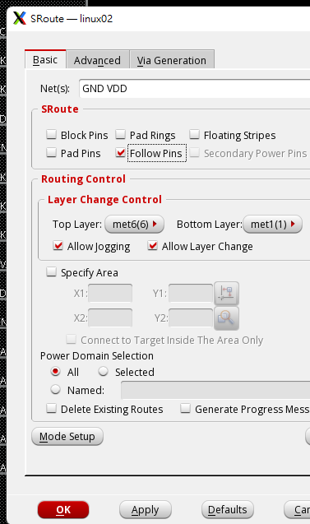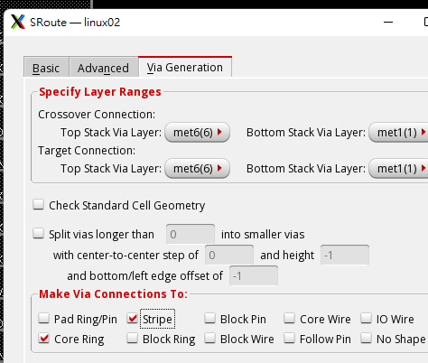

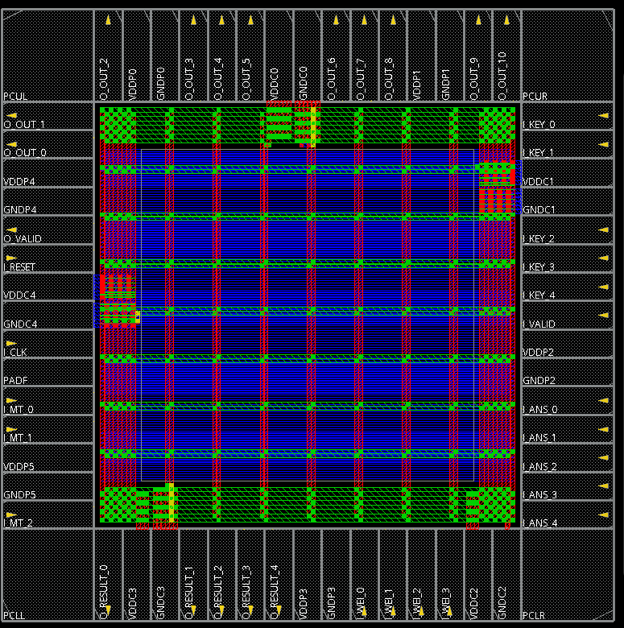

**10. Verify DRC and LVS**

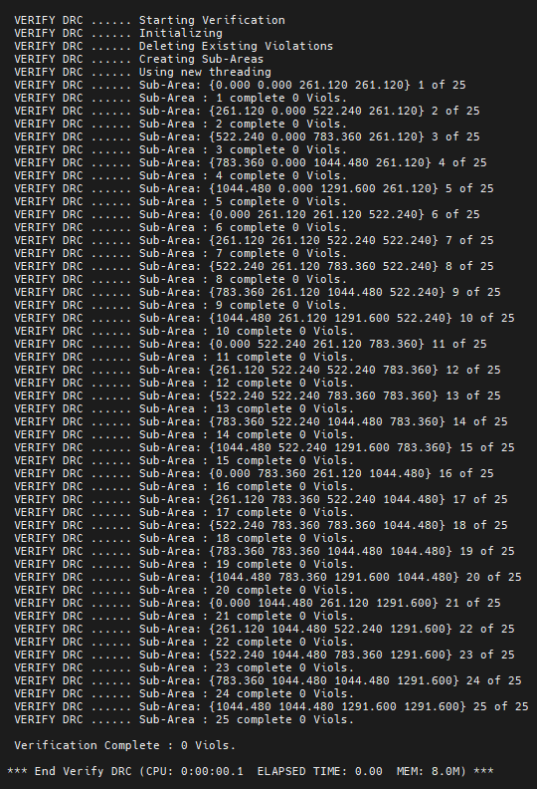 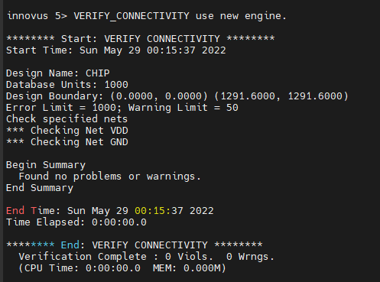

**11. Place Standard Cells**

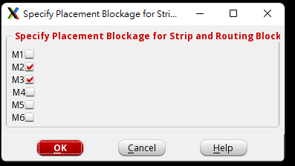

In innovus menu, open ***Place → Place Standard Cells…***

⮚ ◆ Run Full Placement

Optimization Options

⮚ ◇ Include Pre-Place Optimization

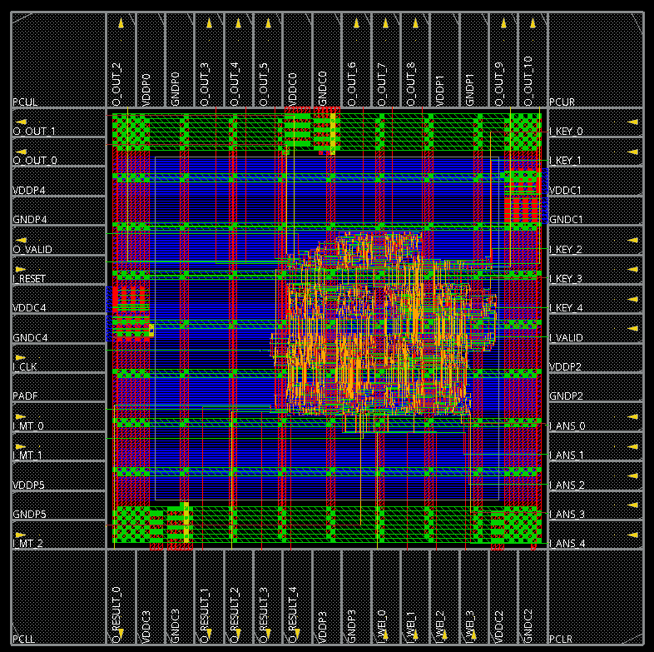

**12. In-Place Optimization (IPO)**

- Before Clock Tree Synthesis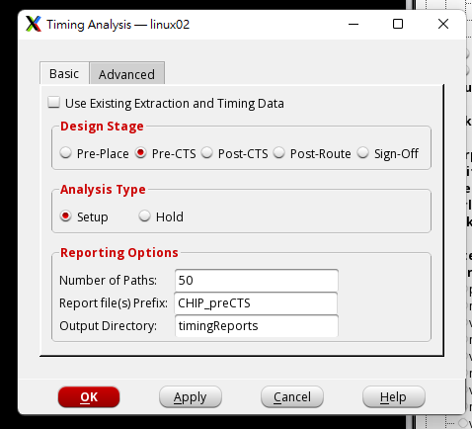

Pre_CTS

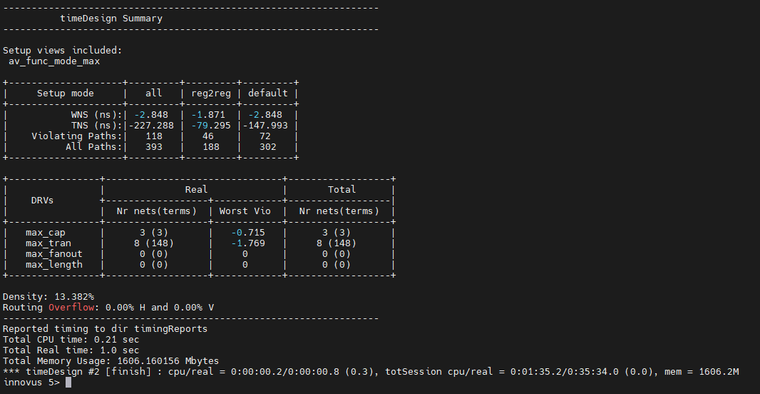

ECO no error , no negative slack DRV=0

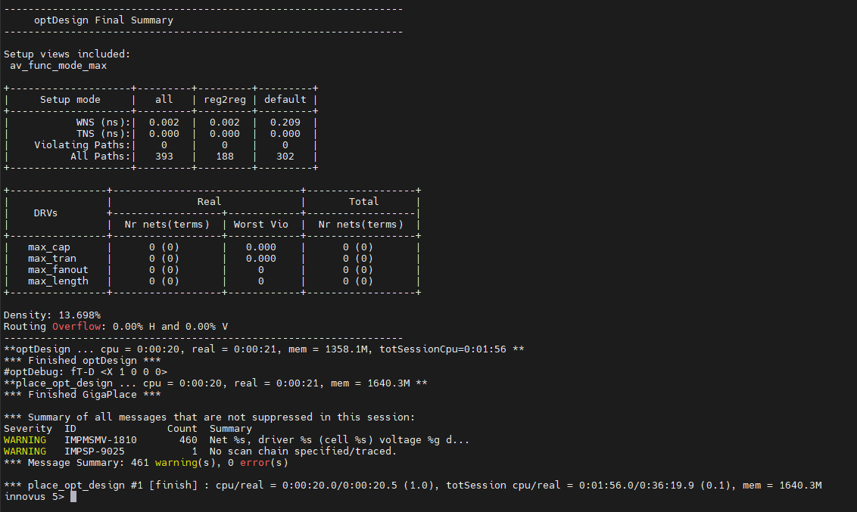

**13. Clock Tree Synthesis (CTS)**

innovus > set_ccopt_property update_io_latency false

innovus > create_ccopt_clock_tree_spec -file CHIP.CCOPT.spec -keep_all_sdc_clocks

innovus > source CHIP.CCOPT.spec

innovus > ccopt_design

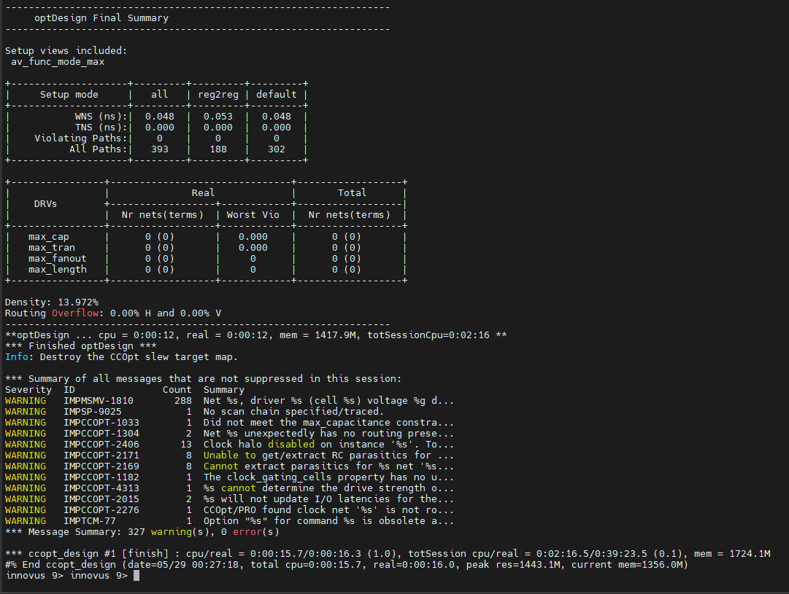

**14. In-Place Optimization (IPO)**

**- After Clock Tree Synthesis**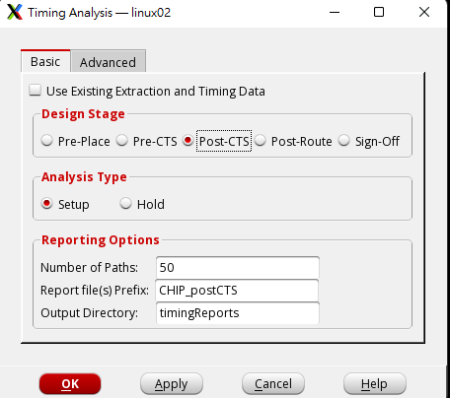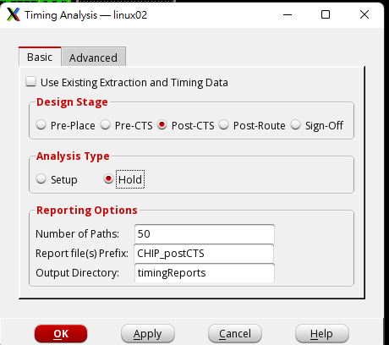

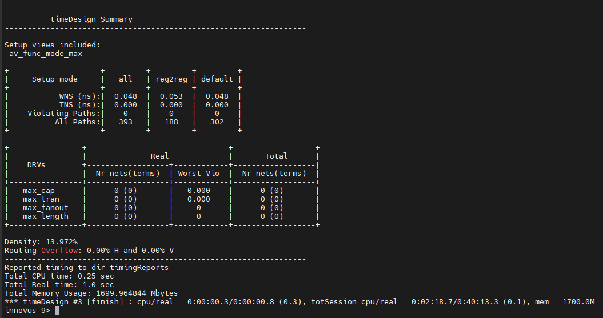

no error , no negative slack, DRV=0

hold time

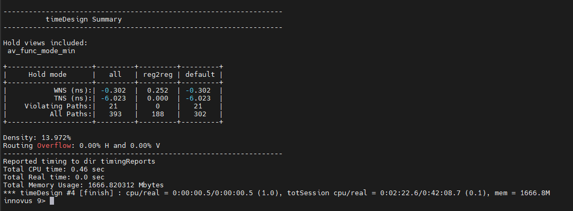

There are negative slack

ECO

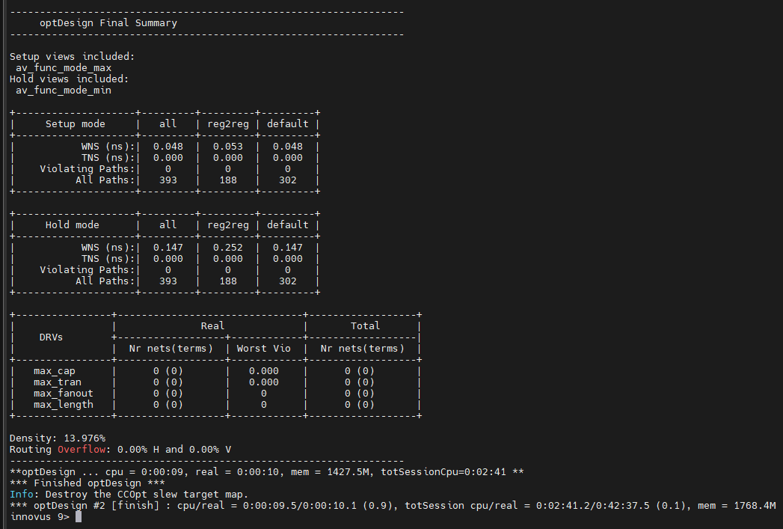

no error , no negative slack, DRV=0

**15. Add PAD Filler**

addIoFiller -cell PFILL -prefix IOFILLER

addIoFiller -cell PFILL_9 -prefix IOFILLER

addIoFiller -cell PFILL_1 -prefix IOFILLER

addIoFiller -cell PFILL_01 -prefix IOFILLER –fillAnyGap

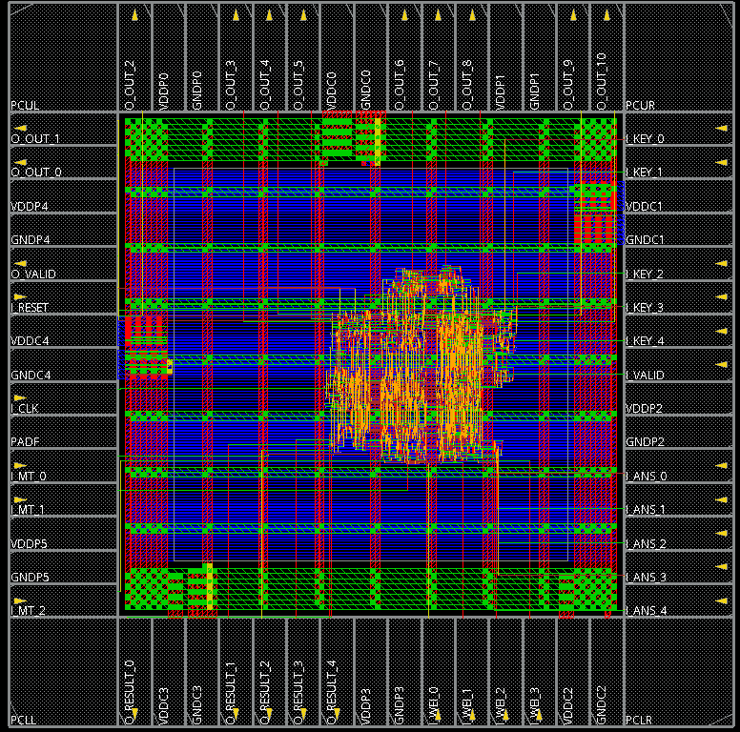

**16. SI-Prevention Detail Route (NanoRoute)**

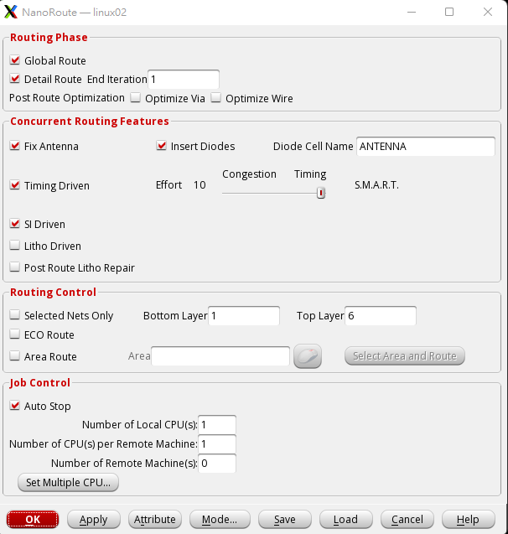

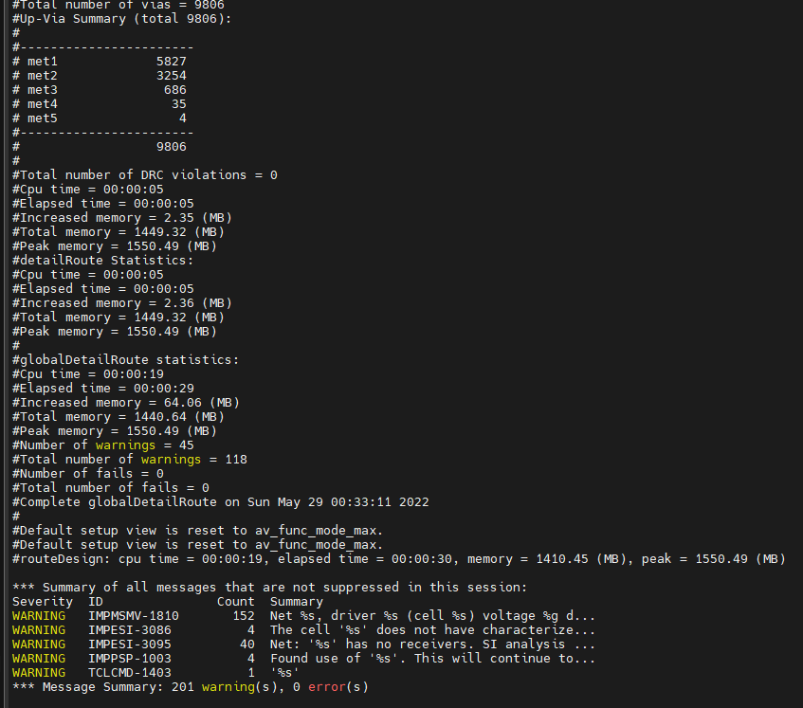

No error

***Verify → Connectivity*** no viols

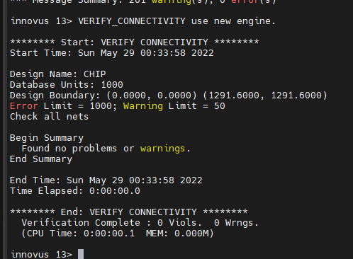

Verify → DRC no viols

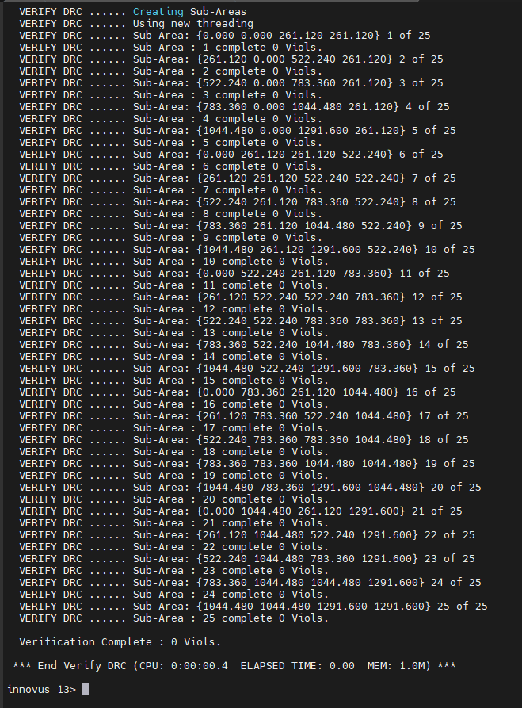

Save design as CHIP_nanoRoute.inn

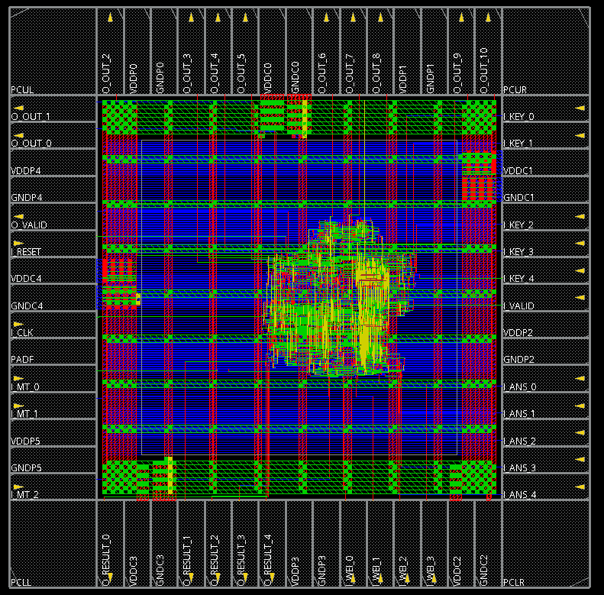

No X at layout

**17. In-Place Optimization (consider crosstalk effects)**

**- After Detail Route** 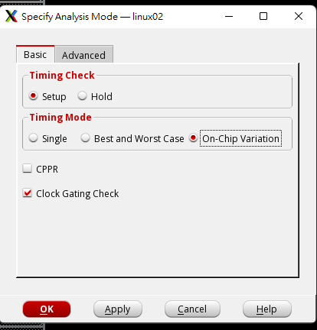 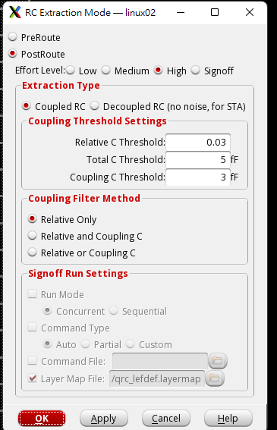

***3. Setting rc and si***

innovus > set_db extract_rc_engine post_route

innovus > set_db extract_rc_effort_level high

innovus > set_db delaycal_enable_si true

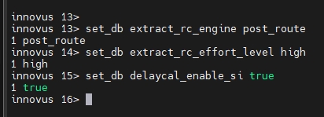

postRoute setup time

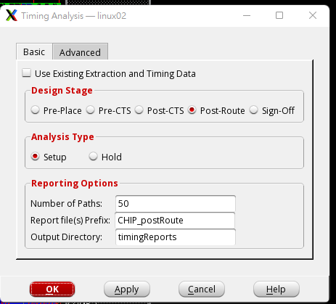 no error , no negative slack, DRV=0

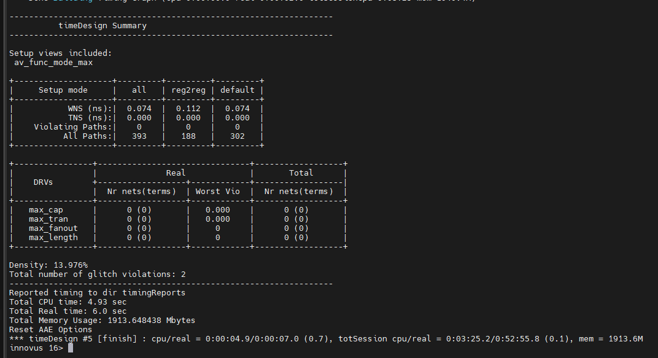

postRoute hold time

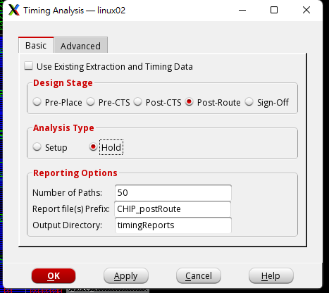 no error , no negative slack, DRV=0

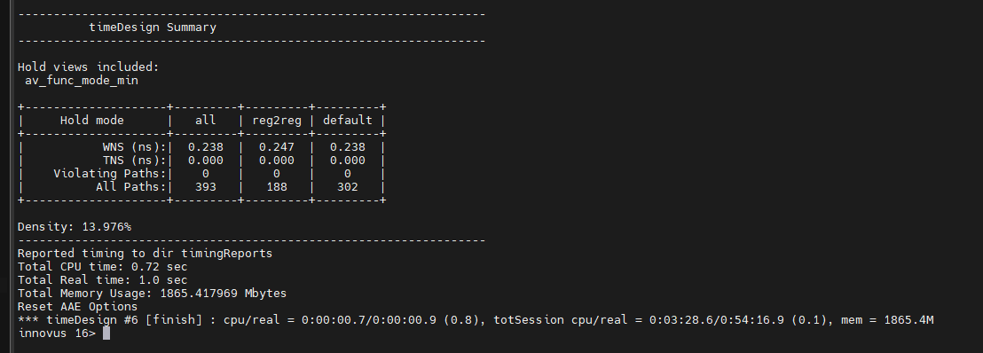

**19. Add CORE Filler Cells**

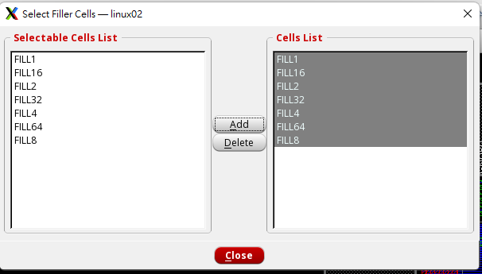 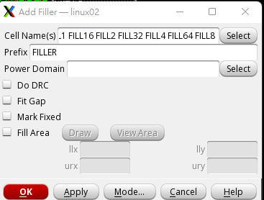

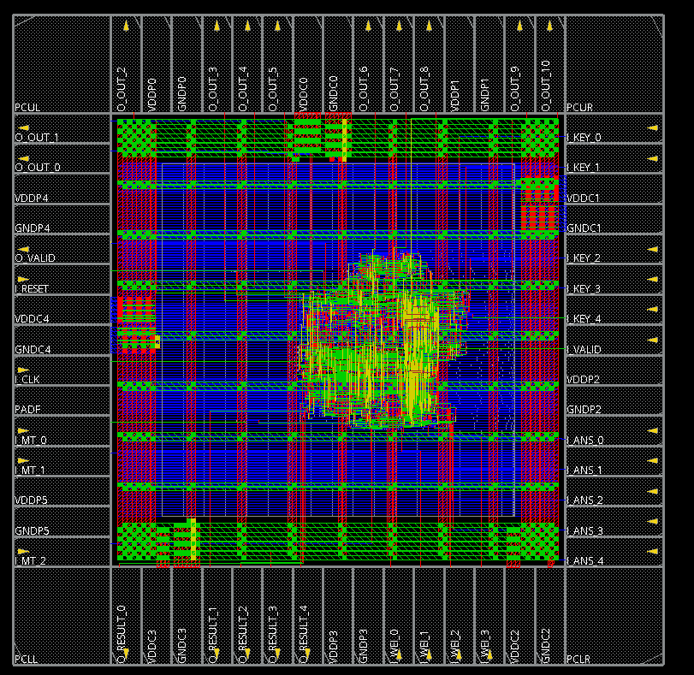

Remember to check DRC / LVS again after placing the fillers.

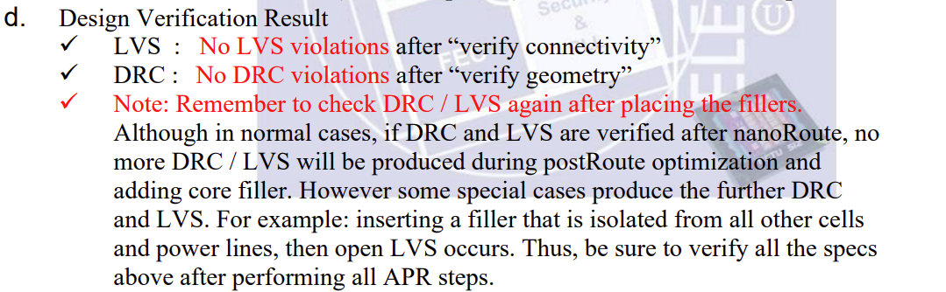

DRC no viols , LVD no viols

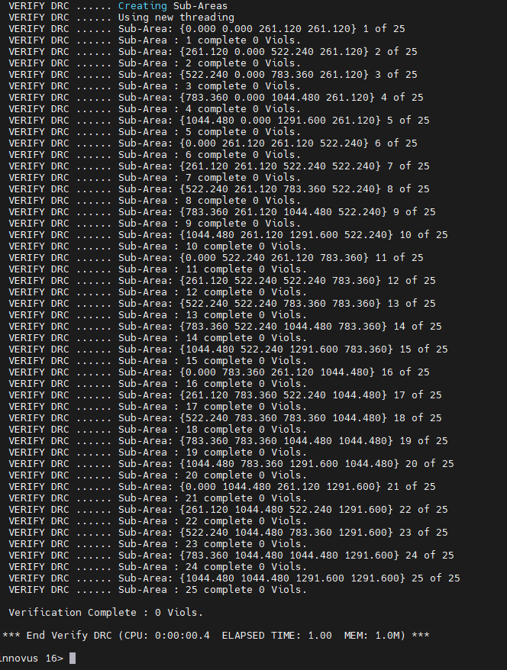 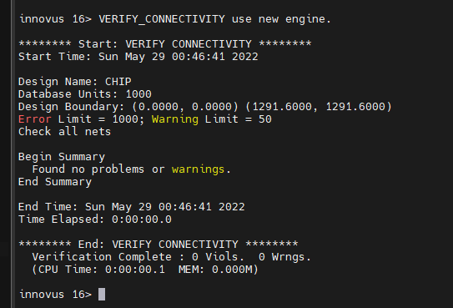

**20. Stream Out and Write Netlist**

1. Save design as CHIP.inn

* 1. 2. Write CHIP.sdf ***a.*** In innovus menu, open ***Timing → Write SDF***
  2. **b. Delay Calculation Option** ⮚ ◇ Ideal Clock (Ideal Clock should be disabled)

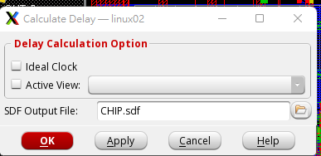

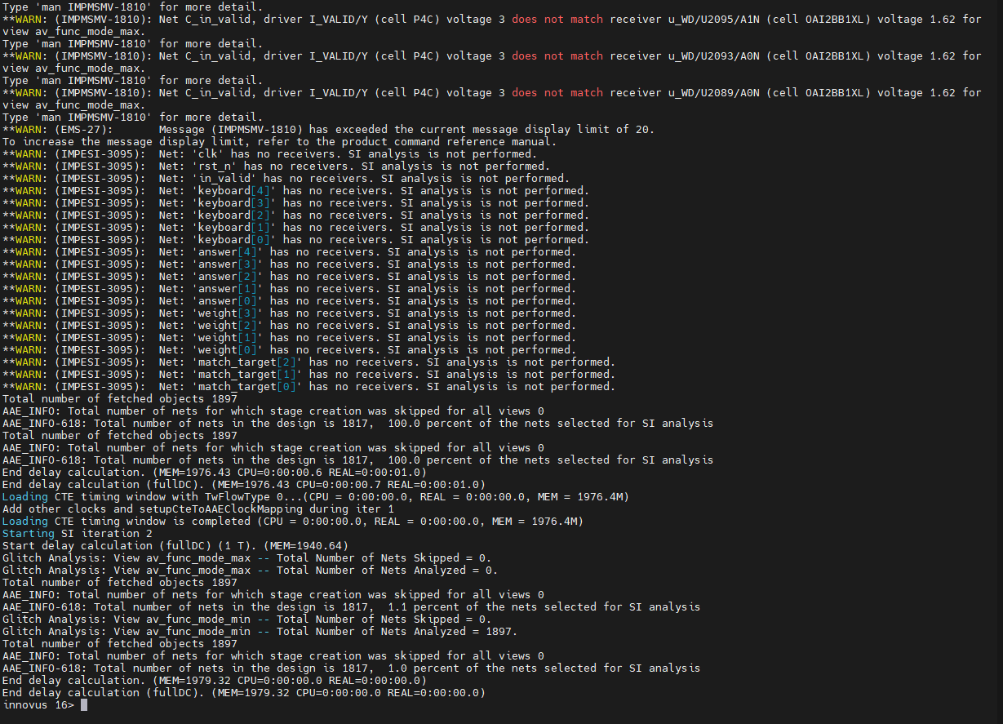

Lots of warn but no error

* 1. Save design netlist CHIP.v for post-layout simulation: ***a.*** In innovus menu, open ***File→ Save → Netlist…***

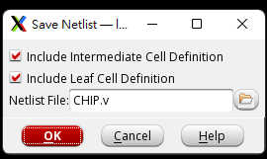 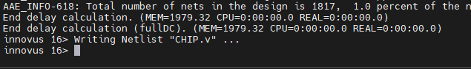

**21. Post-Layout Gate-Level Simulation**

**1.** Change to directory **06_POST**

2. Perform Post-Layout Gate-level simulation of CHIP.v

**% ./01_run** The latency should be the same as gate level simulation

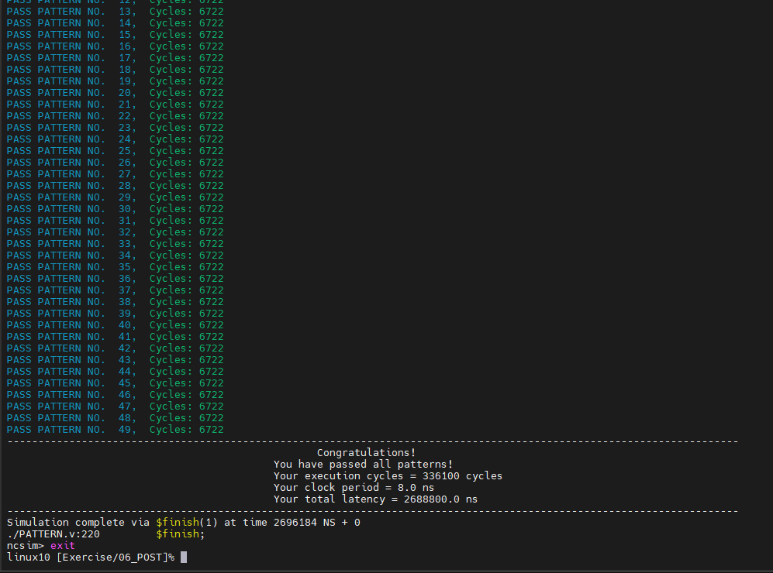

Power part

2. Set environment

cd Lab12/Practice/05_APR

⚫ unix% mkdir power_log (You will save all the things here)

⚫ Restore the design **DBS/CHIP.inn**

3. Static Power Analysis

**1. Save CHIP.v**

**2. Write CHIP.sdf**

**3.** Run post simulation at 06_POST, the generated waveform CHIP_POST.fsdb will be used for power rail analysis.

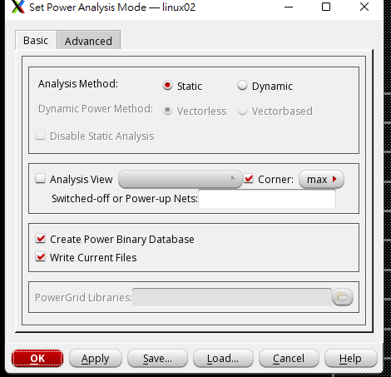

**5.** In the innovus menu, open ***Power*** -> ***Power Analysis*** -> ***Run***

i ◆Activity FILE ◆FSDB

ii. Fill the information:

⚫Select CHIP_POST.fsdb (from 06_POST)

⚫Scope: TESTBED/U_CHIP

⚫ Start: 0; Stop: 100000

⚫ Press Add

* 1. iii. Results Directory: power_log
  2. iv. Click OK.

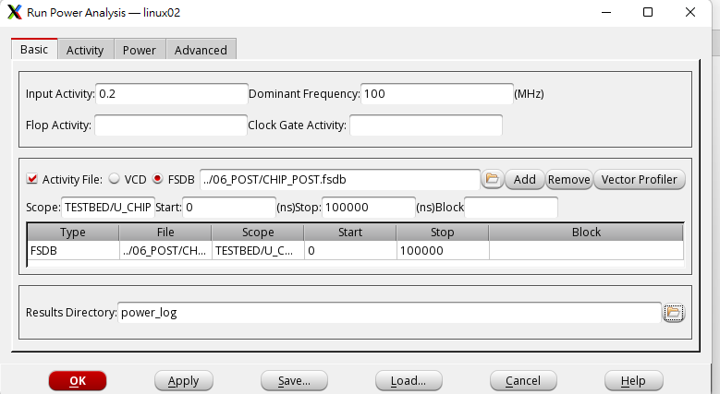

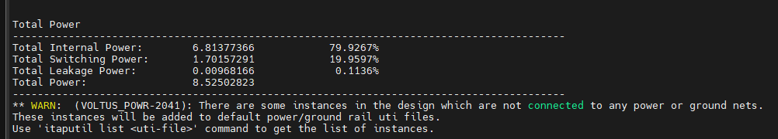

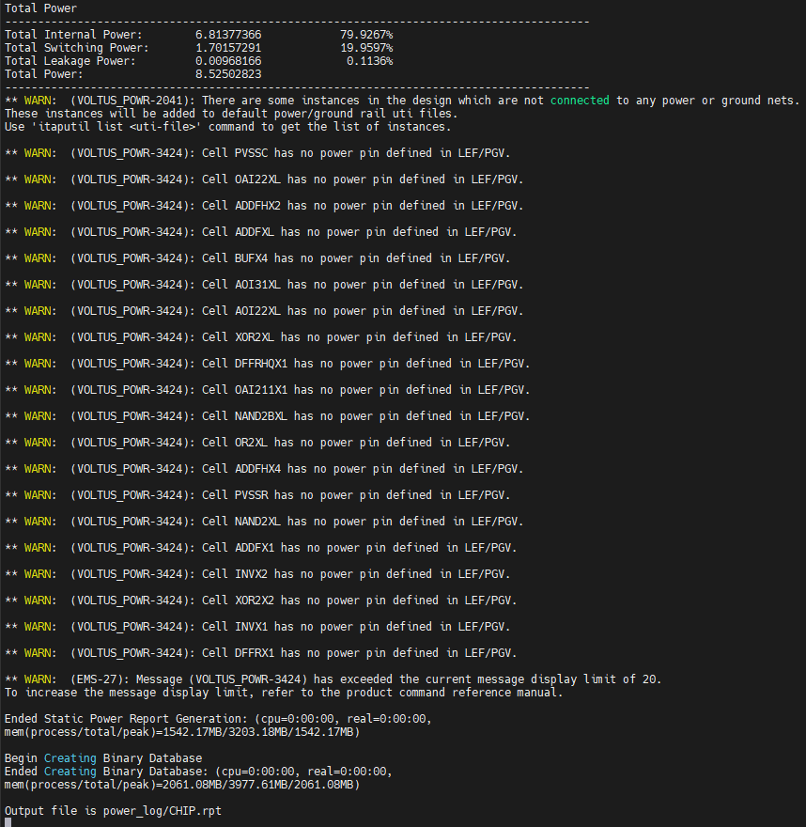

4. Create Power Grid Library

**1.** In the innovus menu, open ***Power*** -> ***Rail Analysis*** -> ***Set PG Library Mode***

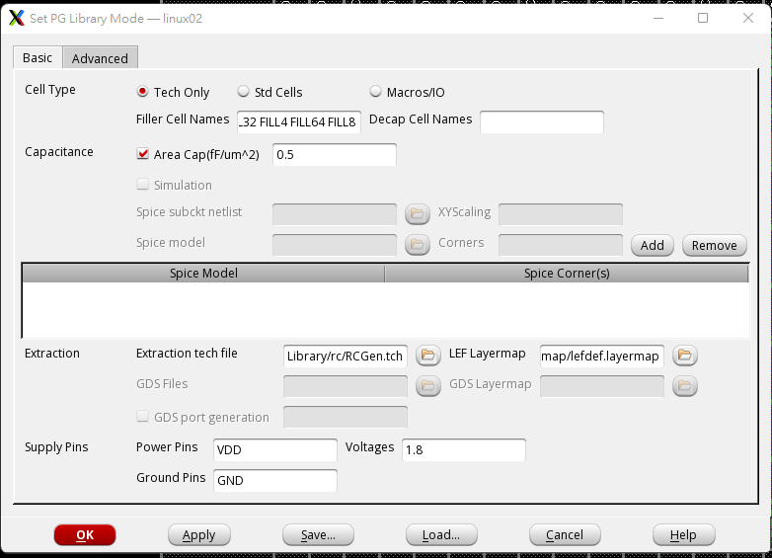

No hard marco so Ground Pins is only GND no VSS



**2.** In the innovus menu, open ***Power -> Rail Analysis -> Generate PG Library***

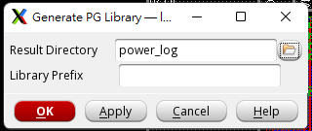

iii. Check if the directory **techonly.cl** exists (under power_log/)

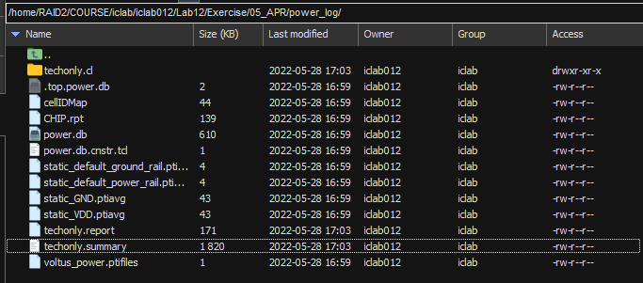

There it is

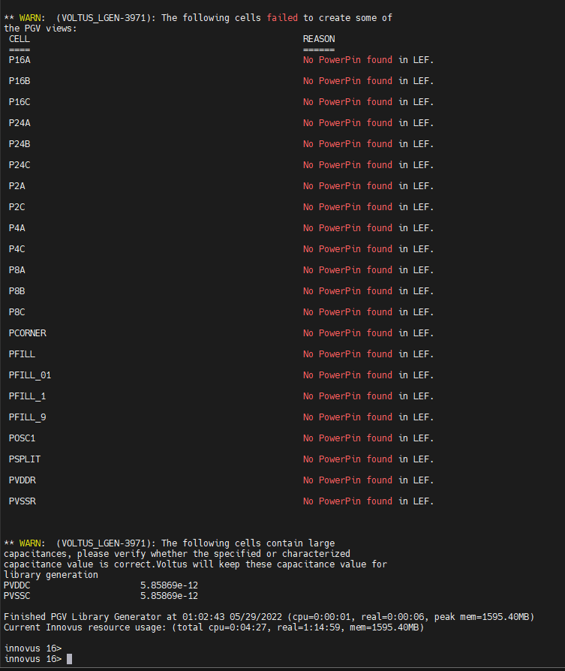 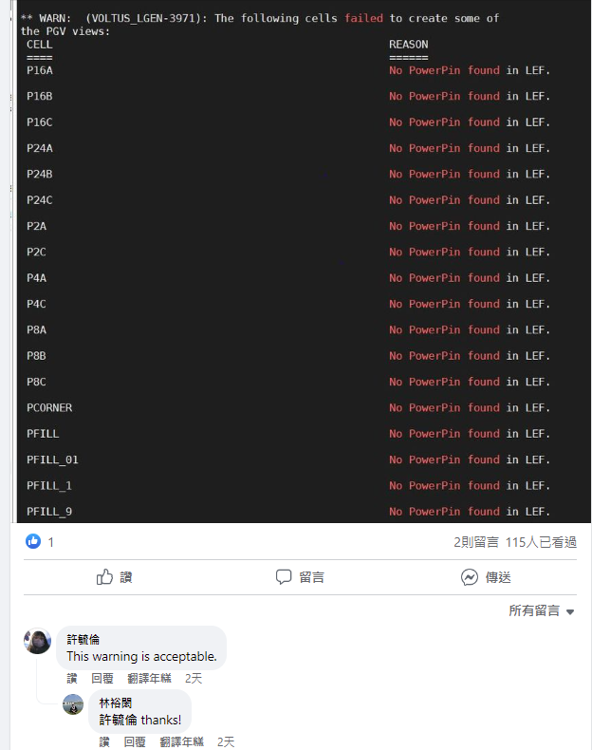

This is acceptable

**3.** In the innovus menu, open ***Power -> Rail Analysis -> Set PG Library Mode***

◆Std Cells

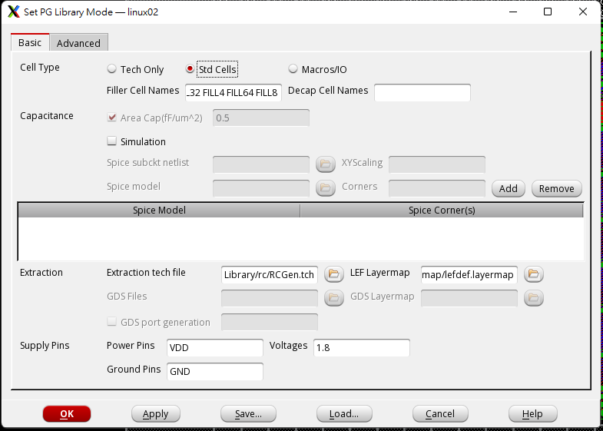

**4.** In the innovus menu, open ***Power -> Rail Analysis -> Generate PG Library***

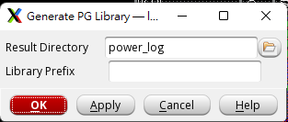

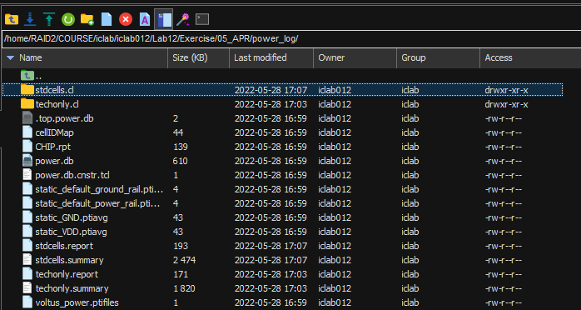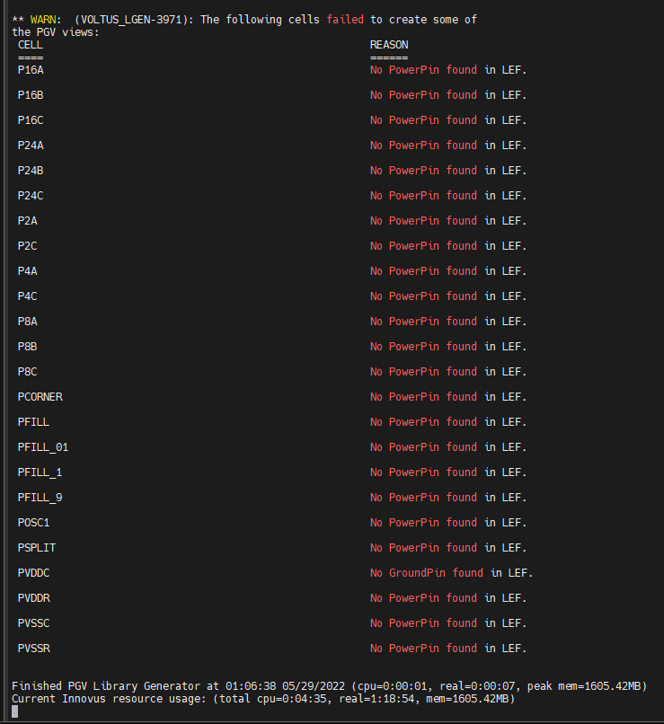

Still have warn and it is acceptable

5. Rail Analysis

**1.** In the innovus menu, open ***Power -> Rail Analysis -> Setup Rail Analysis***

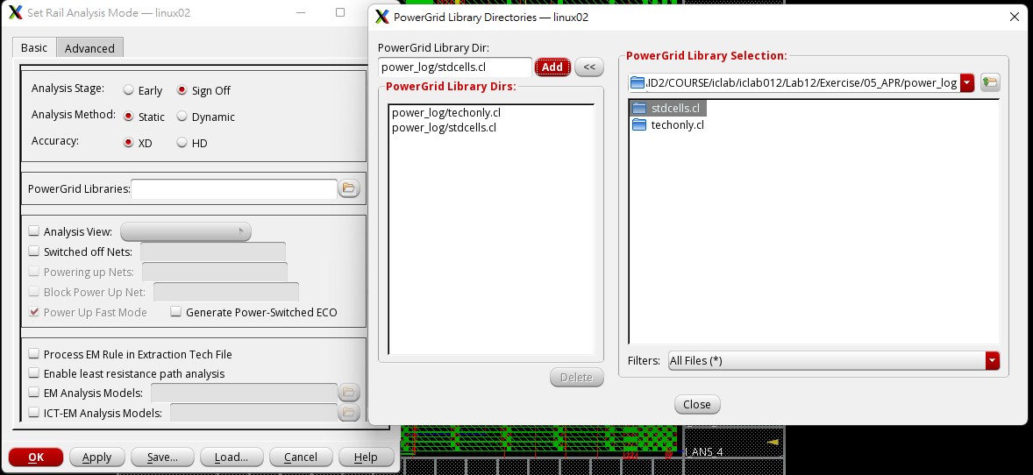

**2.** In the innovus menu, open ***Power -> Rail Analysis -> Run Rail Analysis***

i. ◆ Domain Based Domain Name: PD

ii. Power Net(s): VDD Voltage(s): 1.8 Threshold:1.7 (Press ADD)

iii. Power/Current Files(s):

**power_log/static_VDD.ptiavg**

**power_log/static_GND.ptiavg**

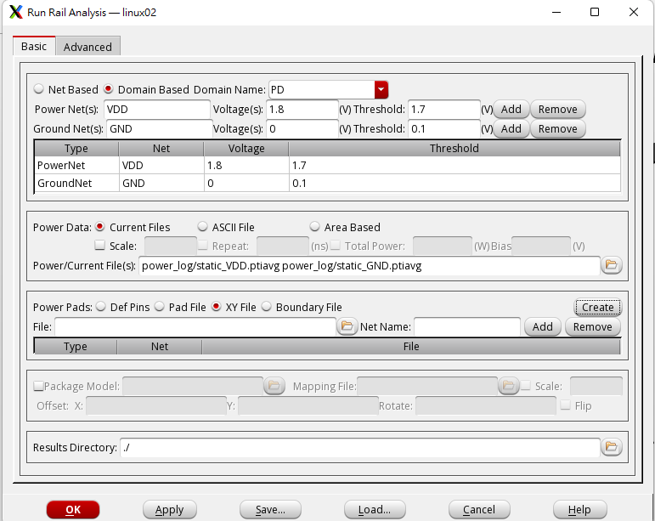

iv. Power Pads: ◆ XY File

v. Click **Create**

Net Name: VDD Click Fetch

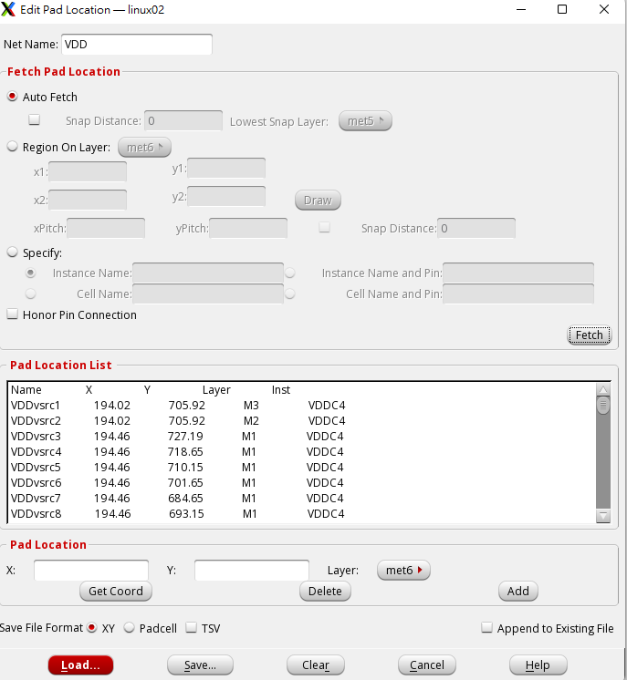Save as **power_log/CHIP_VDD.pp**

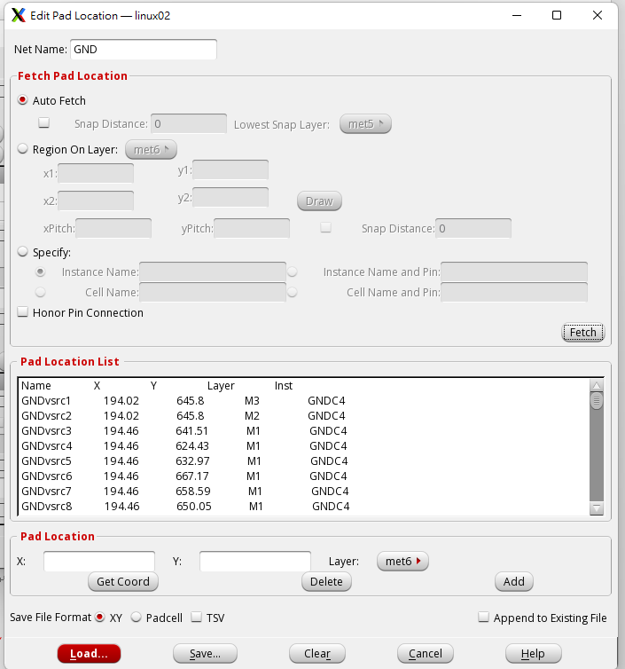 Save as **power_log/CHIP_GND.pp**

File: **power_log/CHIP_VDD.pp** Net Name: VDD (press ADD)

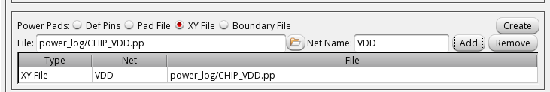

File: **power_log/CHIP_GND.pp** Net Name: GND (press ADD )

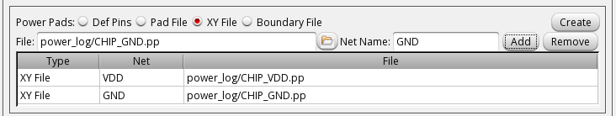

Results Directory: **power_log**

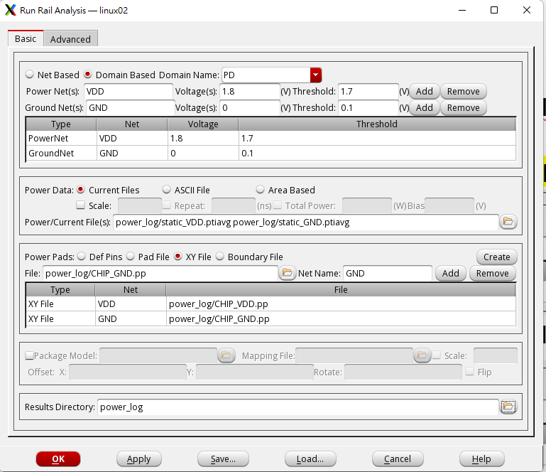 會跑一下

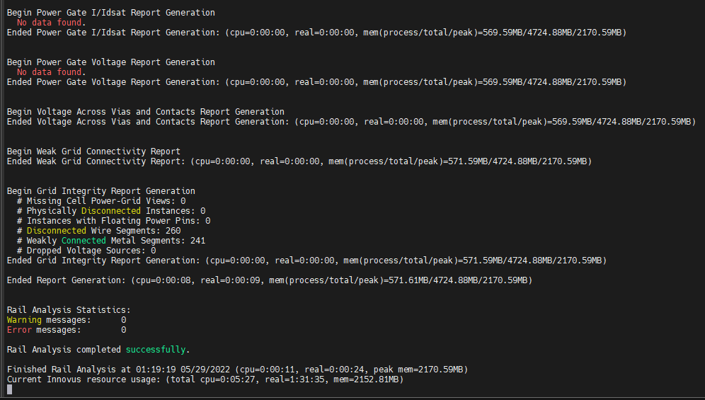

6. Power & IR Drop Results **1.** In the innovus menu, open ***Power -> Report -> Power & Rail Result***

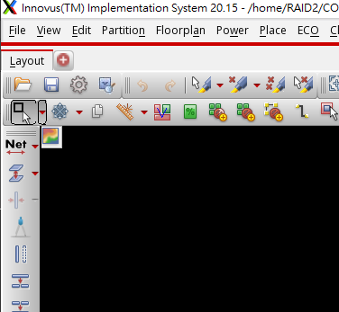回Innovus找左上角那個圖

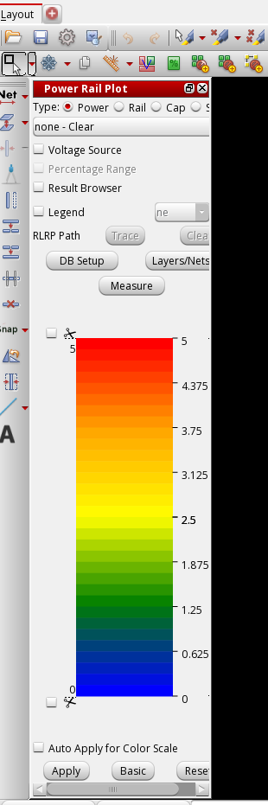點開變這樣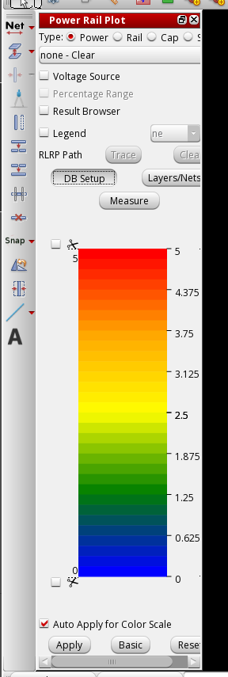 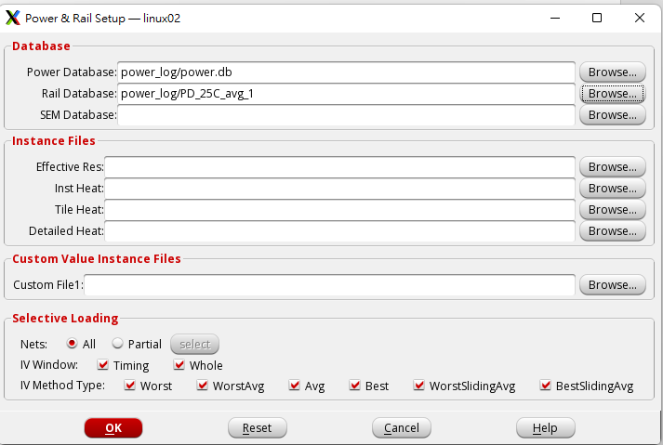

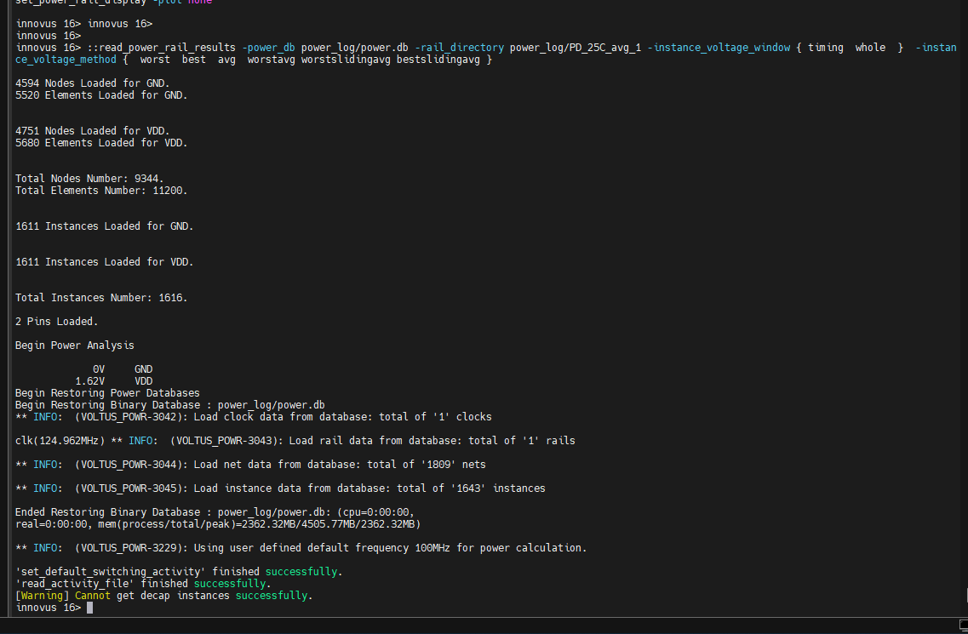

i. ◆Result Browser

The following shows the distribution of IR Drop (they should in the range **0.1V**)

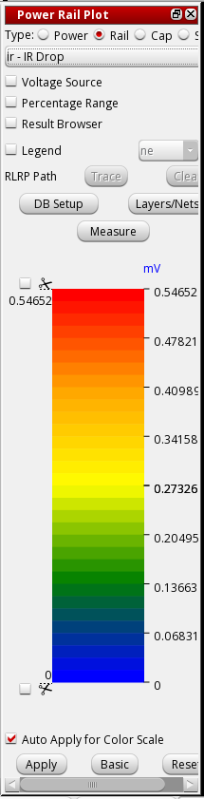 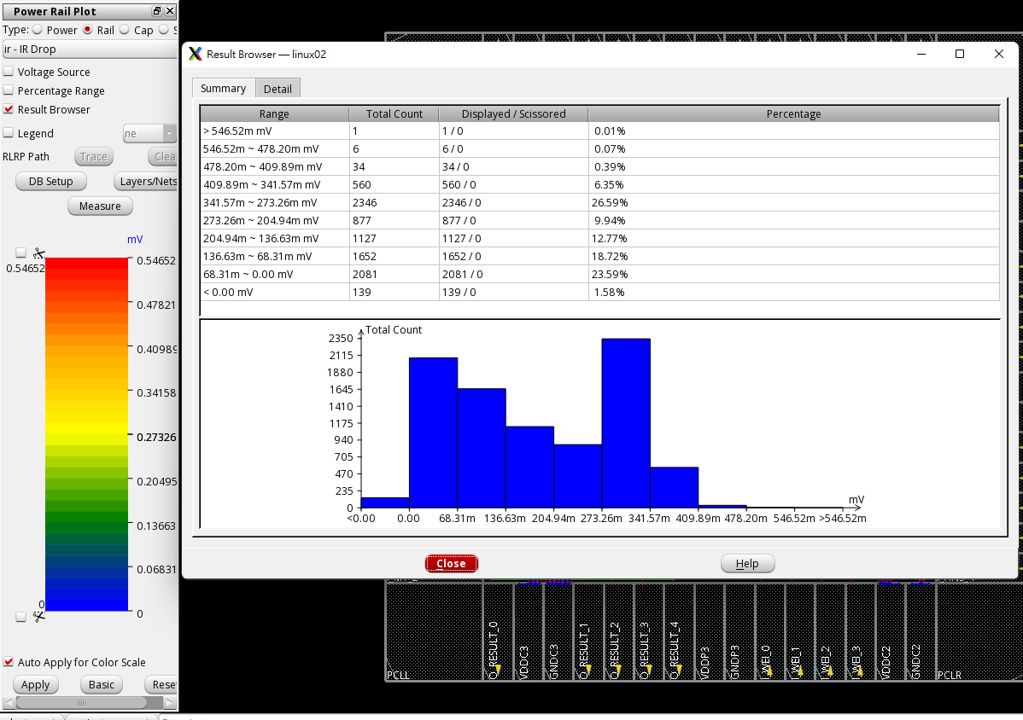

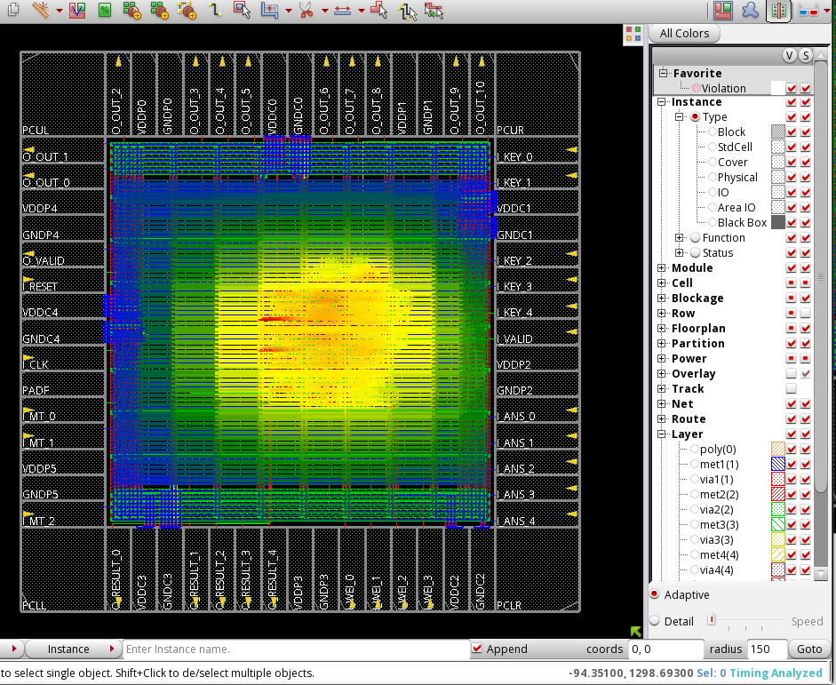

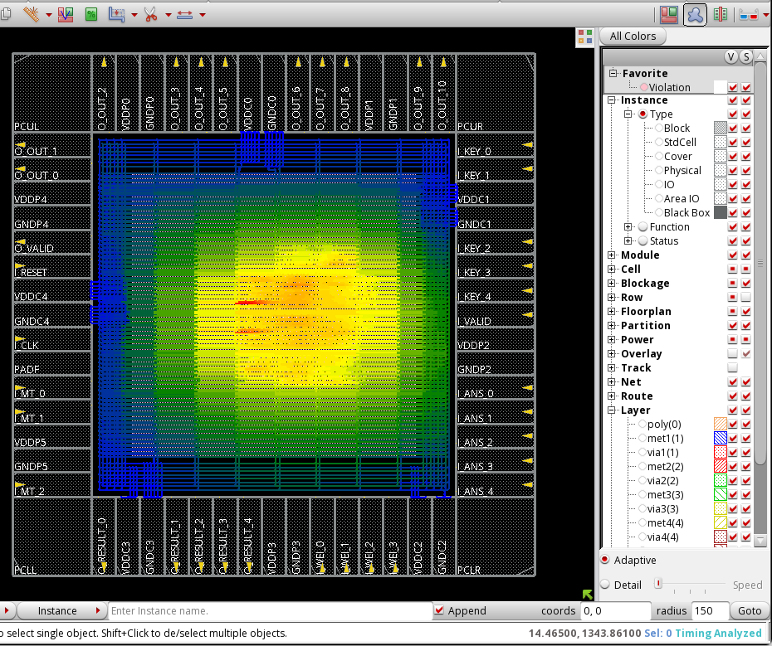

And DONE No IR drop is allowed larger than 5mV